No. of Questions | 04
No. of Pages | 03


UNIVERSITY OF SRI JAYEWARDENEPURA
Faculty of Technology

Bachelor of Information and Communication Technology Honours Degree Academic Year 2021/2022
Fourth Year Second Semester Examination - April 2024
ITC4212: Information Systems Strategy and IT Governance

Duration: Two (2) Hours

Read and follow the instructions given below:

- This paper contains four (4) questions in three (3) pages.
- “Index number” should be written on top of each page of the answer script, and pages must be
numbered appropriately
- Answer all questions

Question 1 Total Marks 25

A. | State four (4) symptoms of poor IT alignment.  - Cancelled projects  - Slow progress  - Systems and tools not fully utilized  - Business users unsatisfied with IS services  - Never enough resources; fighting for resources | (4 Marks)
B. | Define IT maturity.  IT maturity refers to the level of effectiveness, efficiency, and strategic alignment of an organization's IT capabilities in supporting business objectives. | (3 Marks)
C. | Explain the stages of IT maturity and the characteristics associated with each stage.  0 Non-existent - Management processes are not applied at all. no involvement of the top management in IT-related decisions  1 Initial - Processes are ad hoc and disorganized  2 Repeatable - Processes follow a regular pattern  3 Defined - Processes are documented and communicated  4 Managed - Processes are monitored and measured  5 Optimized – Best practices are followed and automated. IT is fully aligned with business strategy. | (6 Marks)
D. | Discuss the evolution of IT functions in an organization with the help of a diagram.  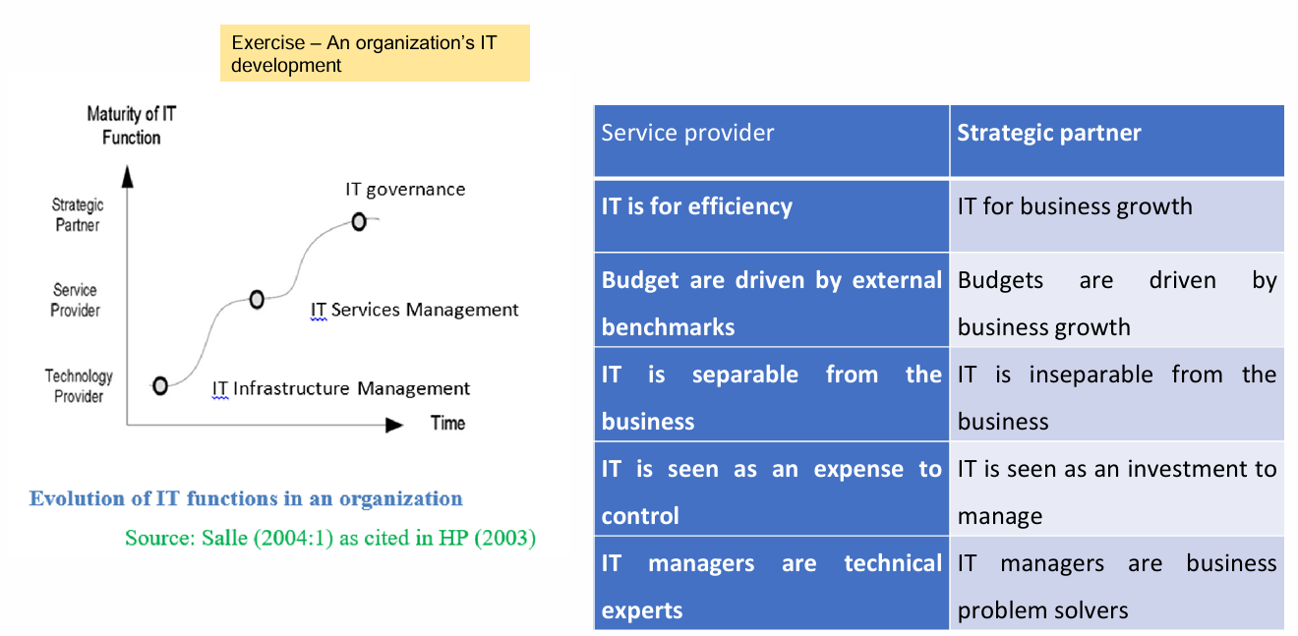 | (6 Marks)
E. | Assess the impact of the external environment on the implementation of IT governance strategies.  - Regulatory Compliance – Laws such as GDPR require organizations to adopt strict IT governance.  - Technological Changes – Emerging technologies like AI and cloud computing demand adaptable IT governance.  - Market Competition – Firms need agile IT strategies to remain competitive.  - Cybersecurity Threats – IT governance must address increasing risks of data breaches. | (6 Marks)

Question 2 Total Marks 25

 | “An organization without an IT governance framework is currently implementing a suitable IT governance framework to optimize the efficient use of its IT resources.” Answer the following questions based on this scenario.
A. | List three (3) ITG frameworks that can be used by the organization  - COBIT  - ITIL  - ISO 17799 | (3 Marks)
B. | Discuss two (2) potential risks and challenges associated with the lack of a structured ITG framework.  - Inefficient Resource Utilization – Lack of governance leads to redundant IT spending and inefficiencies.  - Security and Compliance Risks – Failure to comply with industry regulations can result in legal penalties. | (3 Marks)
C. | Evaluate the impact of three (3) different organizational factors on selecting an appropriate IT governance framework.  - Company Size – Large organizations may prefer COBIT for control, while smaller ones may opt for ITIL.  - Industry Regulations – Heavily regulated industries (e.g., finance, healthcare) may need strict compliance frameworks.  - Corporate Culture – Organizations with a structured culture may implement rigid IT governance, whereas flexible cultures may prefer agile frameworks. | (6 Marks)
D. | Stakeholder involvement is crucial in the selection process of an IT governance framework. Justify the statement with examples.  - Executive managers ensure IT governance aligns with business goals.  - IT Teams provide technical feasibility insights.  - End Users help ensure usability and efficiency.  - Example: A financial institution involving compliance officers when selecting COBIT ensures regulatory alignment. | (6 Marks)
E. | Provide a brief overview of the implementation plan for the selected IT governance framework within the organization  - Assessment – Evaluate existing IT governance practices.  - Framework Selection – Choose a framework (e.g., COBIT).  - Policy Development – Define governance policies.  - Implementation – Deploy tools and train employees.  - Monitoring & Improvement – Continuously review and refine governance processes. | (7 Marks)

Question 3 Total Marks 25

A. | State the main components of a Business Strategy Plan.  Values  Vision  Mission  Strategic objectives  Actions and KPI’s | (5Marks)
B. | Explain the ever-increasing importance of Information Systems in modern organizations. | (6 Marks)
C. | Explain the differences between Vision and Mission statements, considering their focus, timeframe, and content. | (6 Marks)
D. | Describe the Information Systems Strategy Triangle with the help of a neat diagram  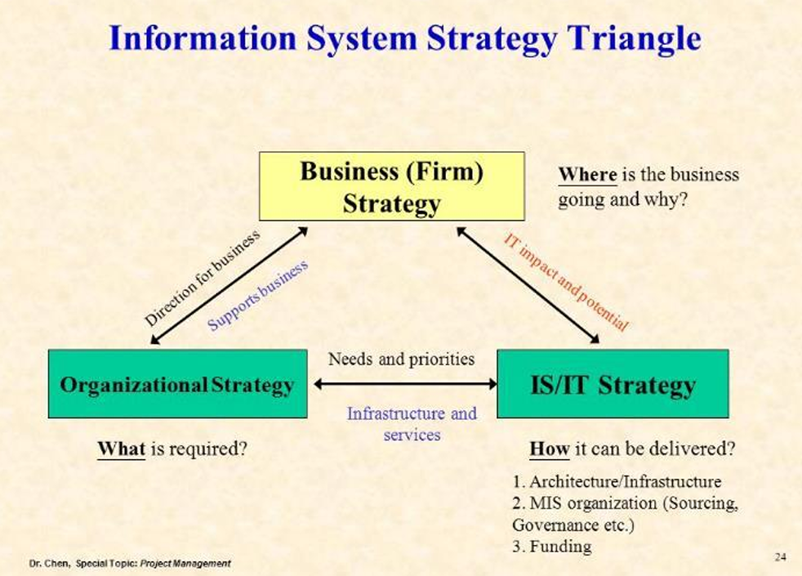  The Information Systems Strategy Triangle represents the alignment between three key organizational strategies:  - Business Strategy – Defines the company’s overall goals and competitive approach.  - Organizational Strategy – Involves structure, culture, and processes that support the business strategy.  - Information Systems Strategy – Focuses on the technology and digital infrastructure that enable business and organizational strategies.  These three elements must be aligned to ensure successful implementation and value creation through information systems. | (8 Marks)

Question 4 Total Marks 25

A. | Explain Porter's Competitive Advantage model with examples. | (5 Marks)
B. | Examine the benefits and strategic advantages of adopting social business strategies within today’s environment. | (6 Marks)
C. | Are Information Systems Strategies critical for implementing strategies in dynamic environments? Justify your answer with the help of an appropriate model. | (8 Marks)
D. | “The strategic planning process encompasses three phases-situation  analysis, strategy formulation, and strategy implementation”. Discuss the statement. | (6 Marks)

***** End of the paper *****

